For immediate release:
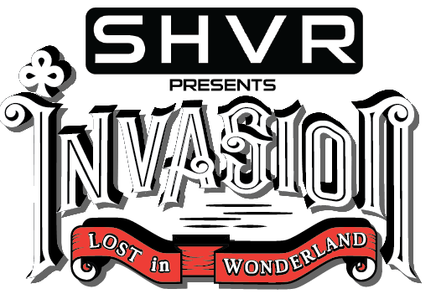

Invasion 2017 Unveils Their First Phase Line-Ups

Martin Garrix, Andrew Rayel and Shonky
- Top DJ’s in the World by DJ Mag confirms to perform at Invasion 2017 in September.
- Bright lights bizarre adventure and the art of surrealism fantasy will dominate this year’s theme, ‘Lost in Wonderland’.
Invasion 2017, an electric dance festival presented by SHVR and organized by Euphorics Events, today announced its first phase line-up confirming 3 international acts through www.invasionjakarta.com. The list includes the #1 DJ’s in the World 2016 by DJ Mag - Martin Garrix, and from Armada music Andrew Rayel who successfully have a music program called Find Your Harmony Radio Show and music producer & French DJ Shonky, more line-ups to be announced very soon.
Entitled SHVR Presents Invasion 2017 - Lost in Wonderland, the festival will take place on 22nd September 2017 at JIExpo Kemayoran Jakarta. “The festival is aimed at enhancing excitement among Indonesia and other countries, such as Malaysia, Singapore, Philippines, Thailand, Australia, Myanmar and Vietnam,” said Dany Setiawan, founder of Euphorics Events. Invasion 2017 will create ‘Lost in Wonderland’ festival ambiance into two party arenas, outdoor and indoor curated stages, along with bright colors bizarre adventure and the art of surrealism decoration to add the feeling of wonder.
“This year, Invasion set theme ‘Lost in Wonderland’ to provide a more exciting electric dance festival experience, featuring live stage performances and feel the experience of bizarre adventure arenas in Surrealism world of fantasy style. It is our commitment to always bring a new concept, for instance last year we presented Imaginarium Mystique Electro Forest, which attracted up to 10,000 attendees. Now, we are targeting to reach 15,000 visitors.” said Dany Setiawan.
For the upcoming Invasion 2017 - Lost in Wonderland, the pre-sale ticket begins today at 7 pm Jakarta Indonesia time. Special offers are applied on pre-sale ticket purchases, as told by Euphorics Events’ representative, Agnes Sendjaja. Thus, there will be three special phases for Invasion 2017 - Lost in Wonderland pre-sale tickets, which are:

Invasion 2017 Lost in Wonderland Ticket prices*:
Pre-sale 1: IDR 400.000,-
Pre-sale 2: IDR 480.000,-
Pre-sale 3: IDR 580.000,-
*) ticket prices above are exclude tax and ticket admin fee.
“We will only sell the pre-sale tickets for limited quantities and can be accessed starting today via Invasion official website at www.invasionjakarta.com ” said Agnes Sendjaja. Otherwise, the full announcement artist line-up of Invasion 2017 - Lost in Wonderland will be revealing soon via Invasion official website as well, for more information please follow us on our official Facebook account, Instagram, and Twitter @InvasionJakarta with hashtag #Invasion 2017.
For media queries, contact:
Helmi Sugara Promotions
PR & Media Relation
+62812-1919-4393
helmisugara@gmail.com
Ainidita : ainindita@gmail.com
Husna Fauzi : husnafauzi@gmail.com
Noppi : noppiya01@gmail.com
Photo
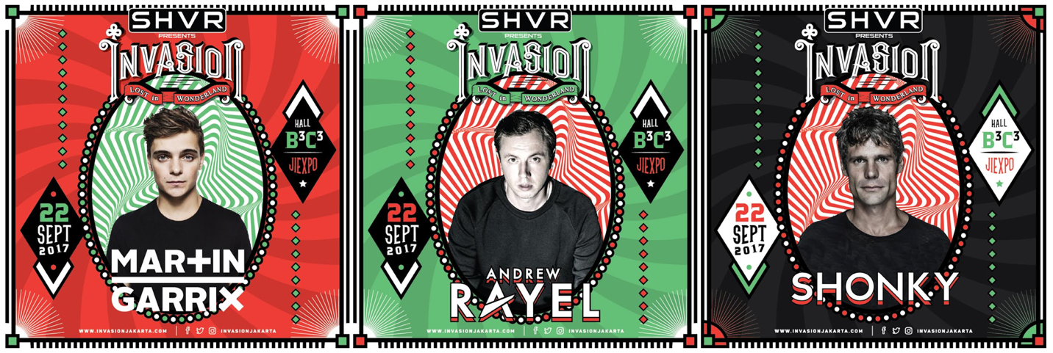
Source:
Related Links:
www.invasionjakarta.com

